Be careful what parameters you put into functions.

I put

Function s(one1, base, end, hafl_xmax, xlenght);

And there was a problem with the one1 function, but it was no cause of the problem. I did not notice the fourth argument is Point type not double but because of that compiler wrongly indicated that the first argument occurred a problem.

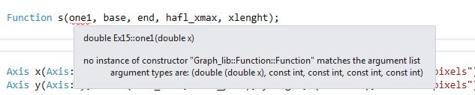

Proper function isL

Function s(one1, base, end, Point(hafl_xmax,hafl_ymax), xlenght);